Dix Chapter 1501
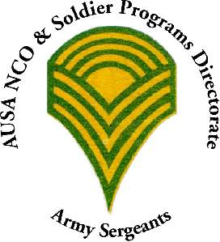  Location:  American Legion Post 294  39 Fort Dix Road (Rte 616)  Pemberton, NJ 08068  Date: 16 February 2017  Time: 5:30 pm  RSVP: by 10 February 2017  (see form below for e-mail address and phone number to reply to) | You are invited to the next Meet/Greet/Social of the Dix Chapter of the Association of the United States Army (AUSA).  Guest speaker to talk on 100 year history of Fort Dix (1917-2017)  Please feel free to pass the flyer onto anyone who might be interested in attending.  Hope to see you at the meeting.  Any questions let me know.  Respectfully,  CSM Arthur G.A. Maggs, Jr., USA, Retired  President, Dix Chapter  1st Region  Association of the United States Army  "Voice for the Army - Support for the Soldier"  “1917 to 2017 - Fort Dix 100 Year Celebration”  “Soldier for Life”

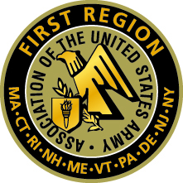

E-Mail/Mail-In Form – Dix Chapter

Rank: _______ Name: ________________________________________________

Retired: Yes _____ No _____

Address: ___________________________________________________________

City ____________________________________ State Zip ___________________

Cell Phone: ________________________ Home Phone: __________________

e-mail address: _____________________________________________________

Unit Organization: ___________________________________________________

Member of AUSA: Yes ______ No ______

There is NO Cost for attending this meeting

Mail-in form to: CSM Arthur G.A. Maggs, Jr., USA, Retired
101 Grace Street, Roselle, N.J. 07203-182l
cell: 908.403.4326
e-mail : agamaggsjr@hotmail.com

