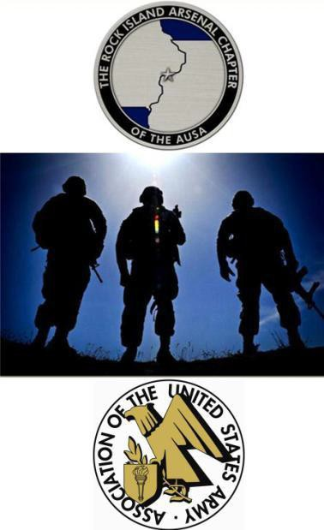
DATE:  TIME: | Friday, Sept 8th, 2017  Registration: | 10:00-10:45 AM
 | Shotgun Start: | 11:00 AM
 | PLAY  Networking and Awards: | 11:00-3:30 PM  3:45-5:00 PM
PLACE: | Arsenal Island Golf Club | www.arsenalislandgolf.com
Rock Island Arsenal
1838 Gillespie St.
Rock Island, IL 61201 (309)793-1604

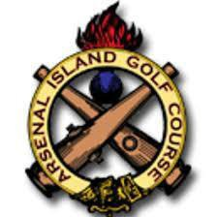

Send Entry Forms to:
RIA AUSA
P.O. Box 3276
Rock Island, IL 61299

Or E-mail them to: jeff.carr@aecom.com
The Rock Island Arsenal Chapter of the AUSA 2017 Golf Outing Entry Form
Voice for the Army – Support for the Soldier

ENTRY FEE: $125.00 per Player/$500.00 per Foursome
(Includes: Green fees/Cart, Lunch & Beverages
Payment Due Aug 25, 2017. 38 Team Limit. Register EARLY!

Make Checks Payable to: RIA AUSA
Mail to: RIA AUSA

P.O. Box 3276
Rock Island, IL 61299

For Credit Card Payment through PayPal Contact:
Jake Ward 309-732-6829 or jward@riafcu.com

Format: Tournament will be a Scramble (preferred ball) format with 4-person teams. If you do not enter as a team, you will be placed with others.

Cancellation Policy:
If golf tournament is cancelled due to weather or other events; or a player cancels after Sept 1st, or is a “no-show”, entry fee is non-refundable.

ENTRY FORM:

NAME:

COMPANY:

Additional Forms may be found at: https://www.ausa.org/chapters/rock-island-arsenal-chapter

ADDRESS:

TELEPHONE:

EMAIL:

Team Members:

Name:

Name:

Name: _

* Please have each player fill out an entry form so we have contact information

